Graphing System of Linear Inequalities

|  |  |
| --- | --- |
| Student Learning Objective: | Essential Question: |

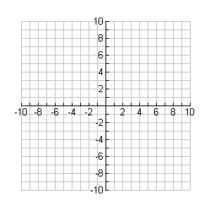Name___________________________________________________ Date___________ Period________

**Bell Work**

Graph the following linear inequality.



**Mini-Lesson (Guided Notes) *Example 1:***

 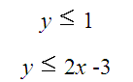

**Steps:**

**How to graph a system of linear**

**Inequalities:**

1. **Graph the two linear inequalities**
2. **The solution set is where the two**

**shaded regions overlap!!!!**

**Work Period: “Graphing Inequalities Partner Activity”**

**Directions:**

1. **Each set of partners will be given a set of linear inequalities to solve for.**
2. **Graph each linear inequality and shade with a different colored pencil.**
3. **The solution set should be labeled with an “S". (the solution set will be where the two colors “overlap”)**
4. **Be sure to test points in the shaded region!!!!!**

**Closure:**

**Explain in words what the “solution set” to a system of linear inequalities means.**

**Regents Prep:**

